Step 0 Intake + Interview Filing Status, Dependency

Interview Notes: (See also: General Notes)
- The McCooks own a home. They paid $11,000 in property taxes for the year. Block: 49 Lot: 2. They do not have a Mortgage.
- Robert McCook is still in High School.

Documents:
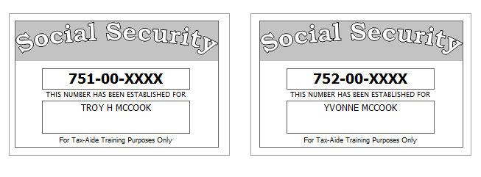
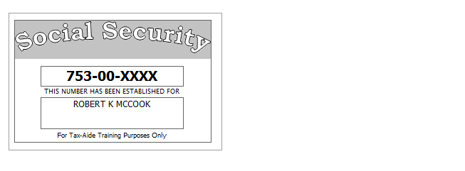

Step 1 Basic Information

TP Form / Note | TS Screen | Notes
 | Basic Information – Filing Status
Intake Sheet | What is your filing Status? | Select Filing status from drop down.  Answer: Filing Status: Married filing jointly  Continue
SS Card  Intake Sheet | Personal Information  Taxpayer Information  Spouse Information  Address & Phone Number | Hint: Use Name and SSN from SS card. (Not Intake Sheet)  Hint: SSN format YYY-00-0752  TS: Birth date can be entered using drop down menu or filling in the field.  TS: Check any of the “Check here” questions that apply –  Hint: Check here if the Spouse wishes to contribute $3 to the Presidential Election Campaign Fund  TS: Spouses last name auto populates when field is selected. Change if required.  TS: Enter Zip code- TaxSlayer fills in city and state. Correct if required  TS: Enter New Jersey as the Resident State  TS: Select Continue
Intake Sheet  G-Note 2,3 | Just a Few More Questions (NJ Info) | TS: Select Municipality from drop down menu (Listed by county). Paterson is in Passaic County. Start typing Passaic to quickly scroll down  TS: Answer question regarding dependent Health Insurance. Answer is Yes.  TS: Select Yes or No for the Gubernatorial Election Fund. See Intake Sheet page 3 and General Note 3. Answer: : No for TP, Yes for SP.  TS: Enter Five Digit Pin for TP and SP. Any 5-digit number.  TS: Select Continue
 | Dependents/ Qualifying Person  Do you have any Dependents or Qualifying Person(s) to claim on your return? | TS: Answer is “Yes”.
 | Dependent/Qualifying Child  Information | Add dependent information  Hint: Use name and SSN from SS card (Not Intake Sheet)  Answer: SSN format = YYY-00-0752  Check the “Check if” questions that apply  Continue

Federal Refund: 0 NJ Refund Amount: 0

Step 2 SSA-1099 Troy & Yvonne McCook
TP Form / Note | TS Screen | Notes
SSA-1099 | Federal Section  Let’s look at the money You earned – Enter Myself  Income  IRA/Pension Distribution Form 1099-R/RRB/SSA  - Begin  Social Security Benefits/RRB-1099 -Begin | Enter SSA-1099 Data  Hint: Use TP4F Scratch Pad to document Medicare Parts B, C, D. Insert total in “Taxpayer’s Medicare Premiums”. Amount = $1,619  TS: Continue, Continue

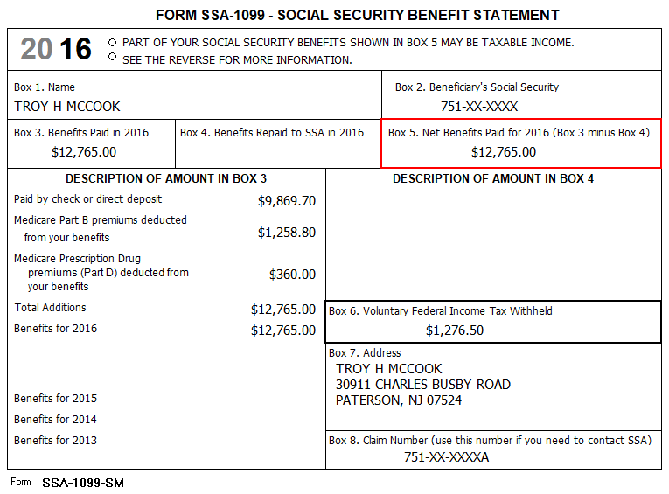

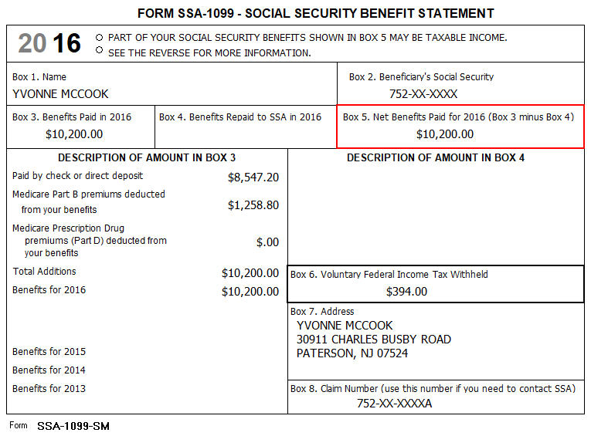

Federal Refund: 1671 NJ Refund Amount: 0

Step 3 Dividends 1099-DIV - Oppenheimer
TP Form / Note | TS Screen | Notes
1099-DIV  Oppenheimer | Interest and Dividends Form 1099-INT/1099-DIV –  Begin  Interest or Dividend Income – Begin  Dividend Income, Form 1099-DIV  Continue | Hint: Select for Taxpayer  Enter values that apply  Continue Until Back to Income

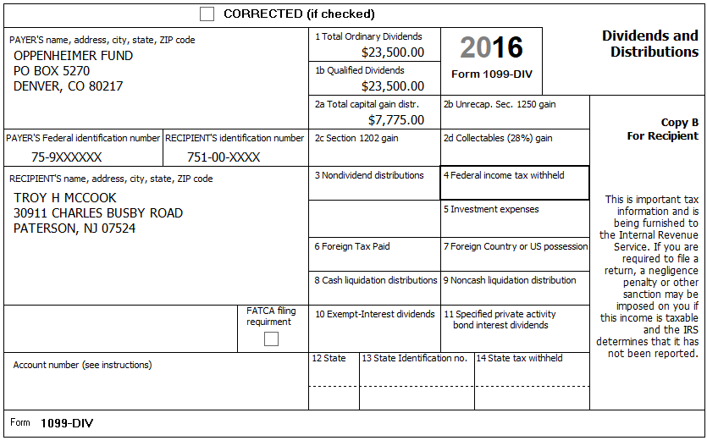

Federal Refund: 1,671 NJ Refund Amount: -342

Step 4 1099-R Ameritech

TP Form / Note | TS Screen | Notes
1099-R  Ameritech | IRA/Pension Distribution Form 1099-R / RBA, SSA – Edit  Add or edit a 1099-R | Hint: “This 1099-R is for Troy  Hint: Make corrections so that information matches the information on the 1099-R  Hint: Taxable amount defaults to Gross Distribution Amount. Adjust as required.  Hint: Did you check the Taxable Amount Not Determined Box?  TS: You do not have to select a State for income to go to the State return.  TS: Continue back to Income

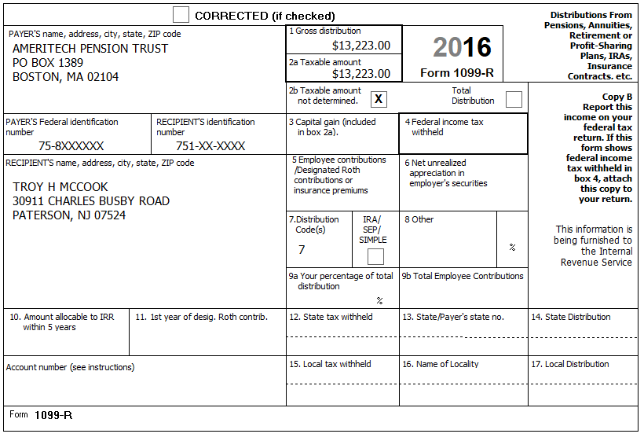

Federal Refund: 1,455 NJ Refund Amount: -342

Step 5 1099-R Phoenix

TP Form / Note | TS Screen | Notes
1099-R  Phoenix Investments | IRA/Pension Distribution Form 1099-R / RBA, SSA – Edit  Add or edit a 1099-R  Add a Form 1099-R IRA/Pension Distribution | Hint: “This 1099-R is for Yvonne  Hint: Make corrections so that information matches the information on the 1099-R  Hint: Taxable amount defaults to Gross Distribution Amount. Adjust as required.  Hint:  Did you check the IRA/SEP/Simple Box?  TS: You do not have to select a State for income to go to the State return.  TS: Continue back to Income

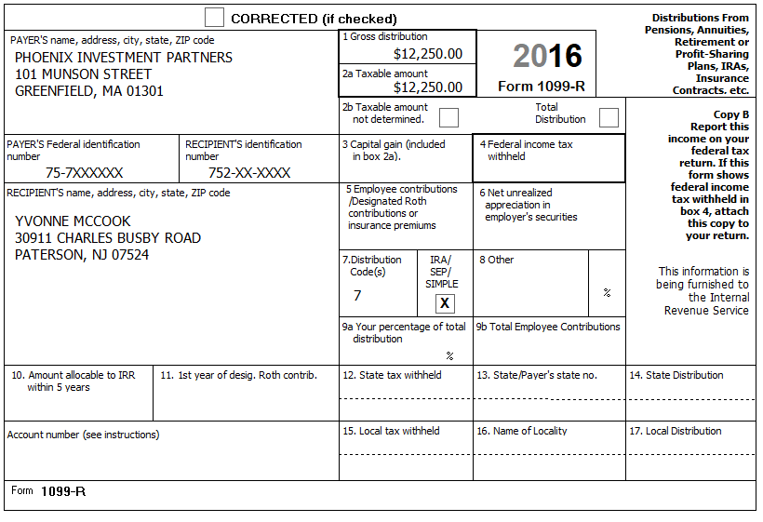

Federal Refund: -102 NJ Refund Amount: -440

Step 6 Itemized Deductions – Taxes You Paid
TP Form / Note | TS Screen | Notes
I-Note 4 | Federal Section  Deductions  Enter Myself  Itemized Deductions - Begin  Taxes You Paid - Begin | TS: Go to the Sales Tax Worksheet and enter NJ and 366 days living in NJ  TS: Continue  TS: Enter real estate taxes paid  Continue Until Health Insurance Introduction

The McCooks own a home. They paid $11,000 in property taxes for the year. They do not have a Mortgage

Federal Refund: -102 NJ Refund Amount: -440
Step 7 Compare Standard vs Itemized Deductions

TP Form / Note | TS Screen | Notes
 | Federal Section  Deductions  Enter Myself  Compare Deductions - Begin | Check to see if using itemized deductions or standard deductions. Itemized = 11,912  Std = 15100  Continue

Federal Refund: -102 NJ Refund Amount: -440
Step 8 Health Insurance

TP Form / Note | TS Screen | Notes
G-Note 2 | Left Menu  Health Insurance  Start Questionnaire | Answer questions in the Health Insurance Section

Every person on the return had health insurance that met Minimum Essential Coverage rules for the entire year. They did not purchase it through the marketplace.

Federal Refund: -102 NJ Refund Amount: -440

Step 9 New Jersey Return

TP Form / Note | TS Screen | Notes
I-Note 1  G-Note 2,3,4 | State Return –Edit  Enter Myself  Basic Information  Credits  - Property Tax Deduction | Hint: Use the NJ Checklist to enter NJ items  HINT: Check Basic Information – Default values will not appear as selected  Credits  Hint: Use scratch pad at TP4F to determine the proper value for Property Tax Paid  Hint: Property Taxes Paid = $11,000  Hint: Taxpayer meets Property Tax Eligibility Requirements  Hint: TP was a Homeowner in 2016  Hint: County Property located in: Passaic County-Paterson  Continue back to the beginning of the State Return

They had no out-of-state purchases on which they did not pay Use tax
The McCooks own a home. They paid $11,000 in property taxes for the year. Block: 49 Lot: 2. They do not have a Mortgage

Federal Refund: -102 NJ Refund Amount: -268
Step 10 Prepare for e-file

Intake Sheet  G Note 5 | Left Menu – e-file – | TS – Clear up any diagnostic messages (if any)  TS: Select Federal Return Type “E:file: Mail Payment”  TS: No entries in Fees section except for Client email address  TS – Pin numbers for e-file are automatically selected  TS: Select State Refund Type “E:file: Mail Payment”  TS: Skip Third Party Designee Info  TS – Questions – Answer questions from Intake sheet Part VII, lines 5.6 and 7, Supplemental Intake Sheet,  TS: Skip TP ID Information Screen  Save  You are Done

They want to handle any state refund / amount due like their federal refund / amount due

Federal Refund: -102 NJ Refund Amount: -268

